- Switching and VLANS

Q.1 Draw a simple network diagram showing three devices (like your laptop, a friend's phone, and a smart TV) connected to a switch, and label which device is in which VLAN (e.g., VLAN 10 for streaming, VLAN 20 for personal devices)?

Answer

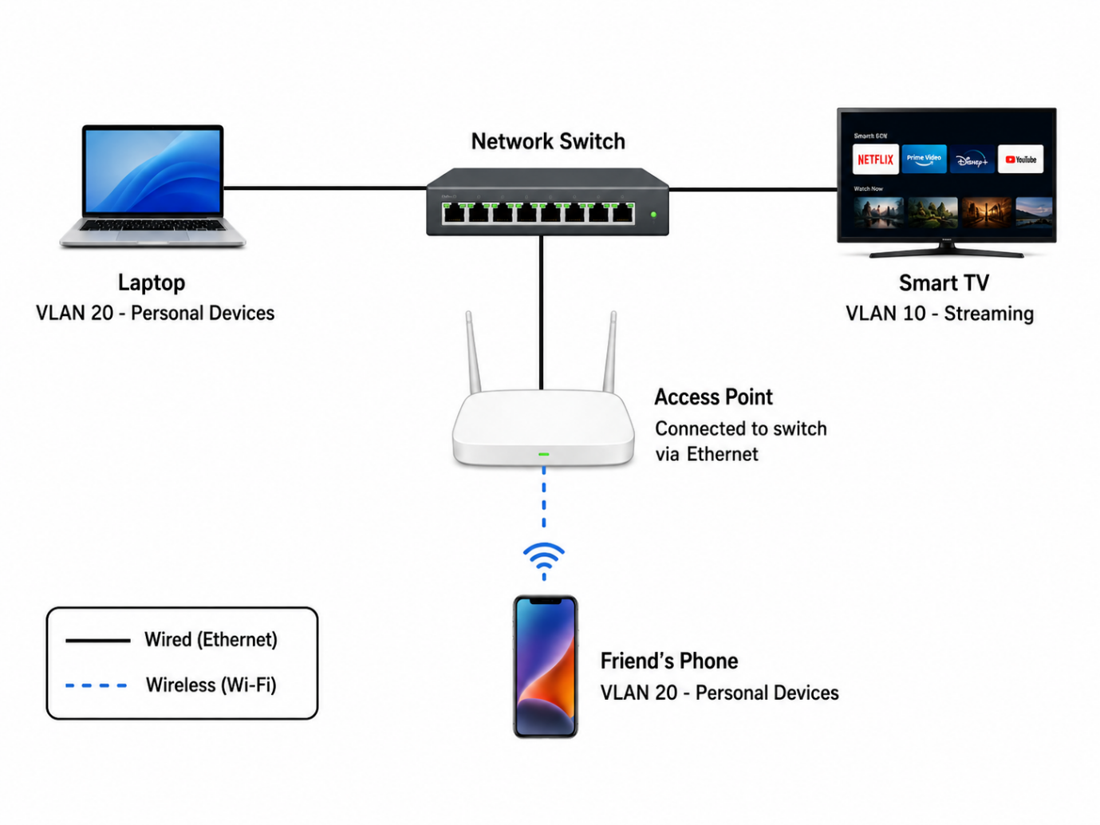

The diagram shows three devices connected to a network switch using VLANs. The laptop and friend’s phone are in VLAN 20 for personal devices, while the Smart TV is in VLAN 10 for streaming. The laptop and Smart TV connect to the switch using Ethernet cables. The phone connects wirelessly through an access point, which is connected to the switch by Ethernet. VLANs help separate different types of devices into different logical networks.

Q.2 Configure a simulated switch using Cisco Packet Tracer or NetSim: create two VLANs (VLAN 10 and VLAN 20), assign three PCs to VLAN 10 and two PCs to VLAN 20, and verify that PCs in different VLANs cannot ping each other.<br><br><em><strong>Hint:</strong> Use the 'vlan' and 'switchport access vlan' commands in the simulator CLI.</em>?

Answer
- VLAN Configuration in Cisco Packet Tracer
I created a network using one Cisco 2960 switch and five PCs.
- VLAN 10: PC0, PC1, PC2
- VLAN 20: PC3, PC4
The switch ports Fa0/1 to Fa0/3 were assigned to VLAN 10, and Fa0/4 to Fa0/5 were assigned to VLAN 20.
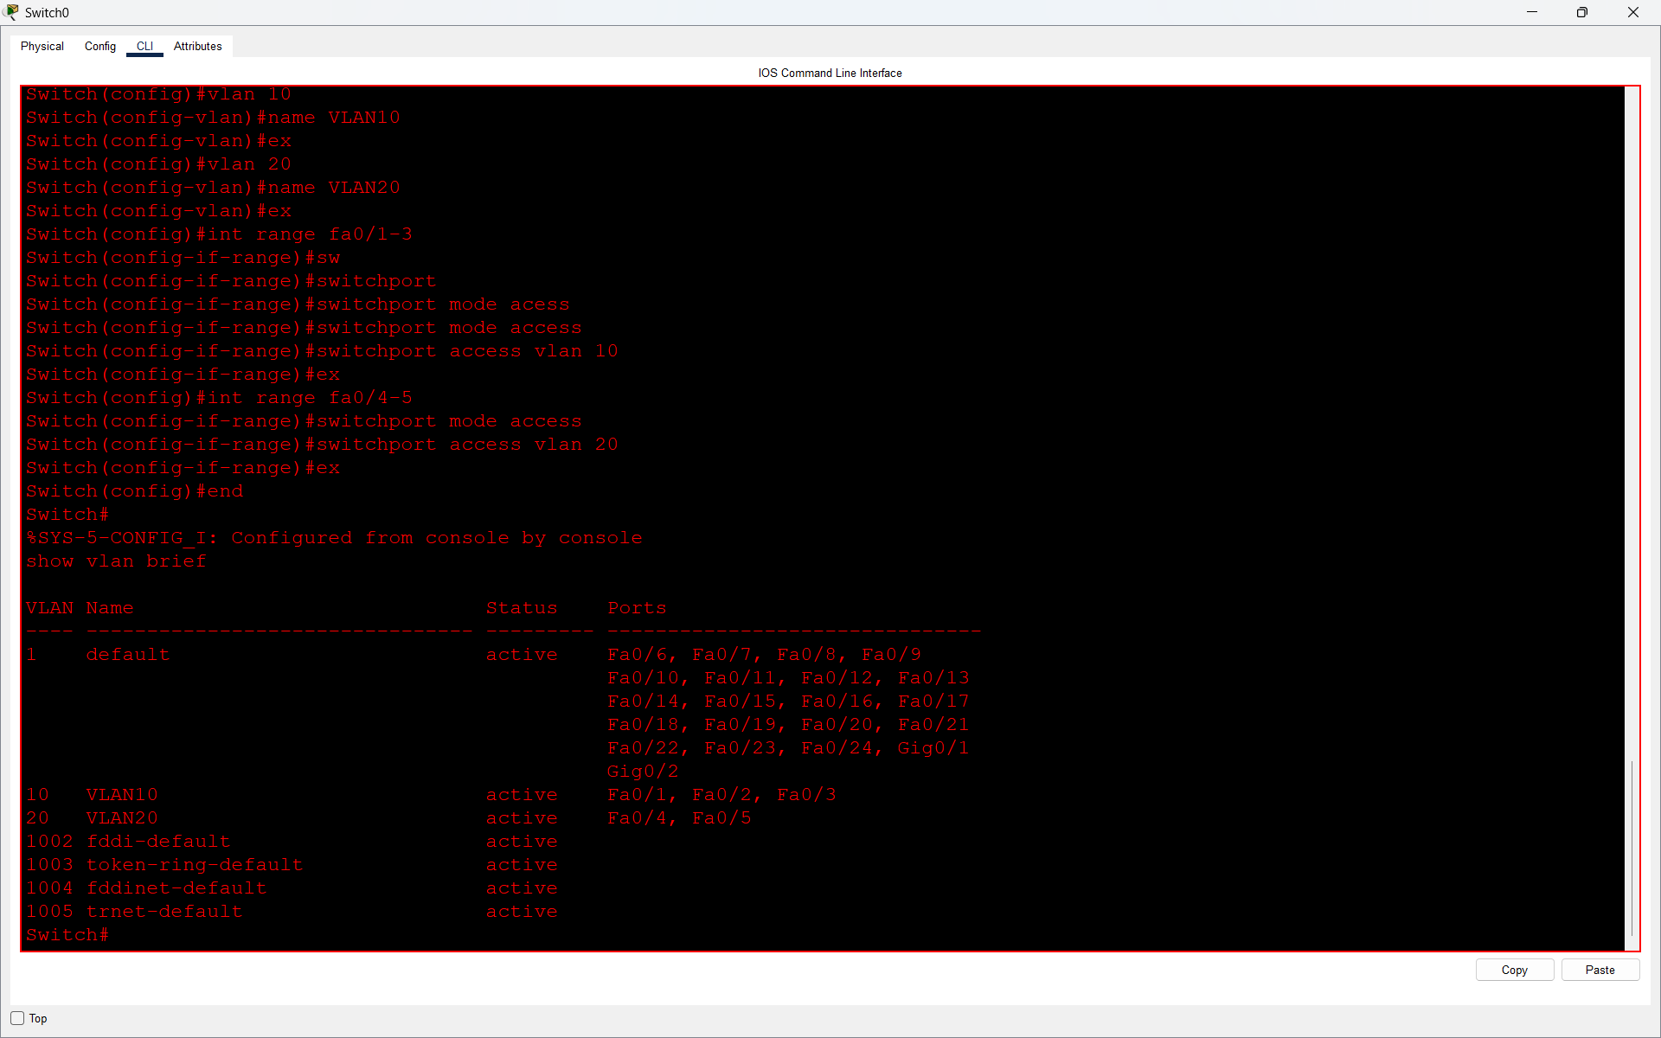

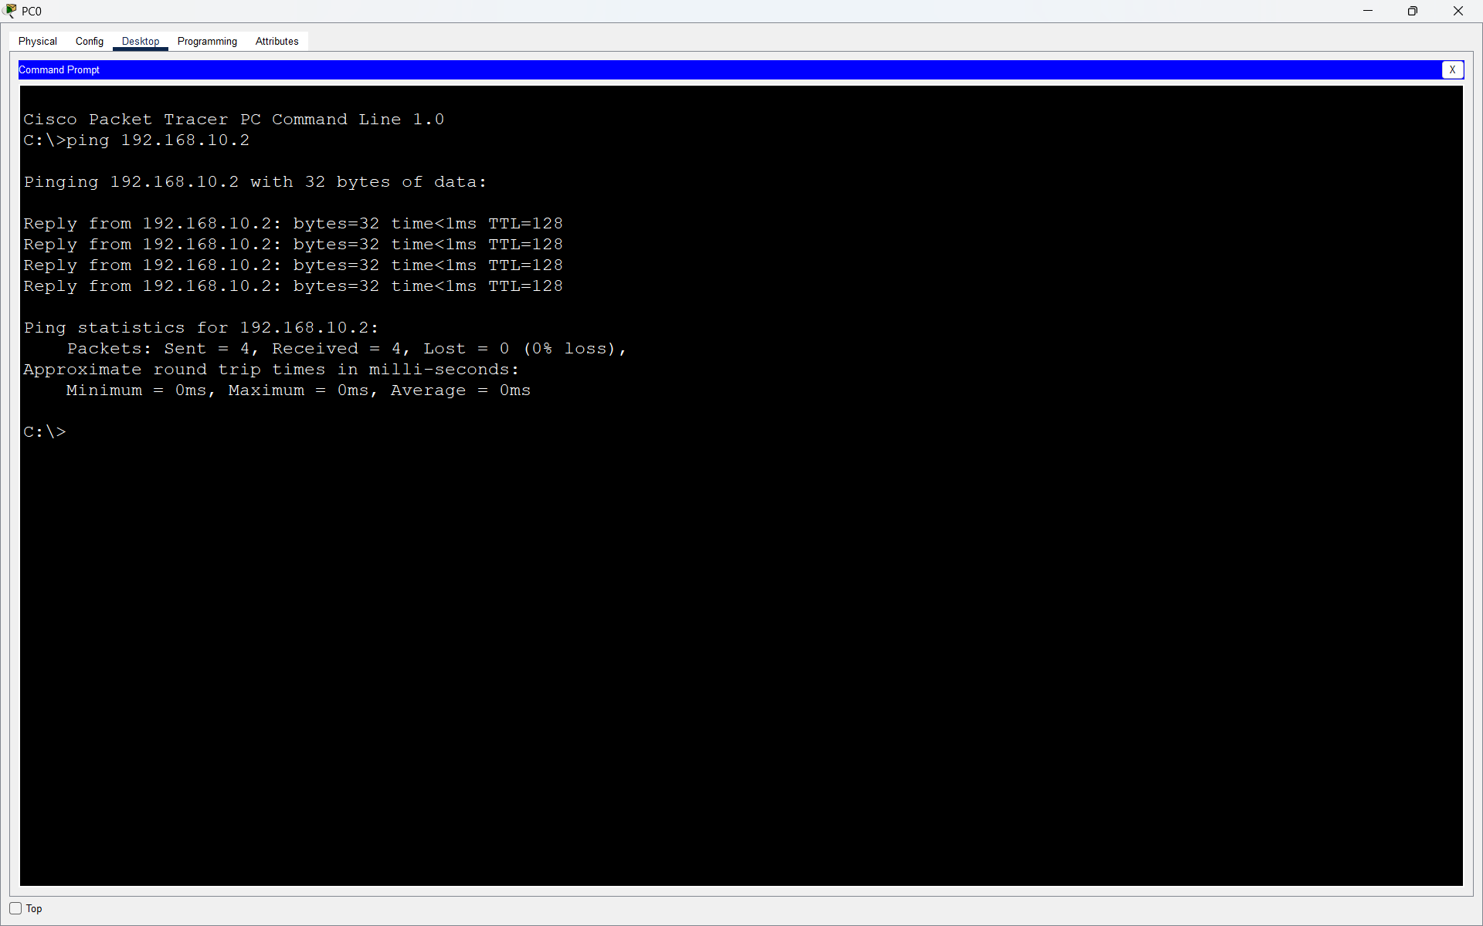
I tested connectivity between PCs. PCs in the same VLAN were able to communicate successfully.

I then tested communication between a PC in VLAN 10 and a PC in VLAN 20. The ping failed with 100% packet loss.
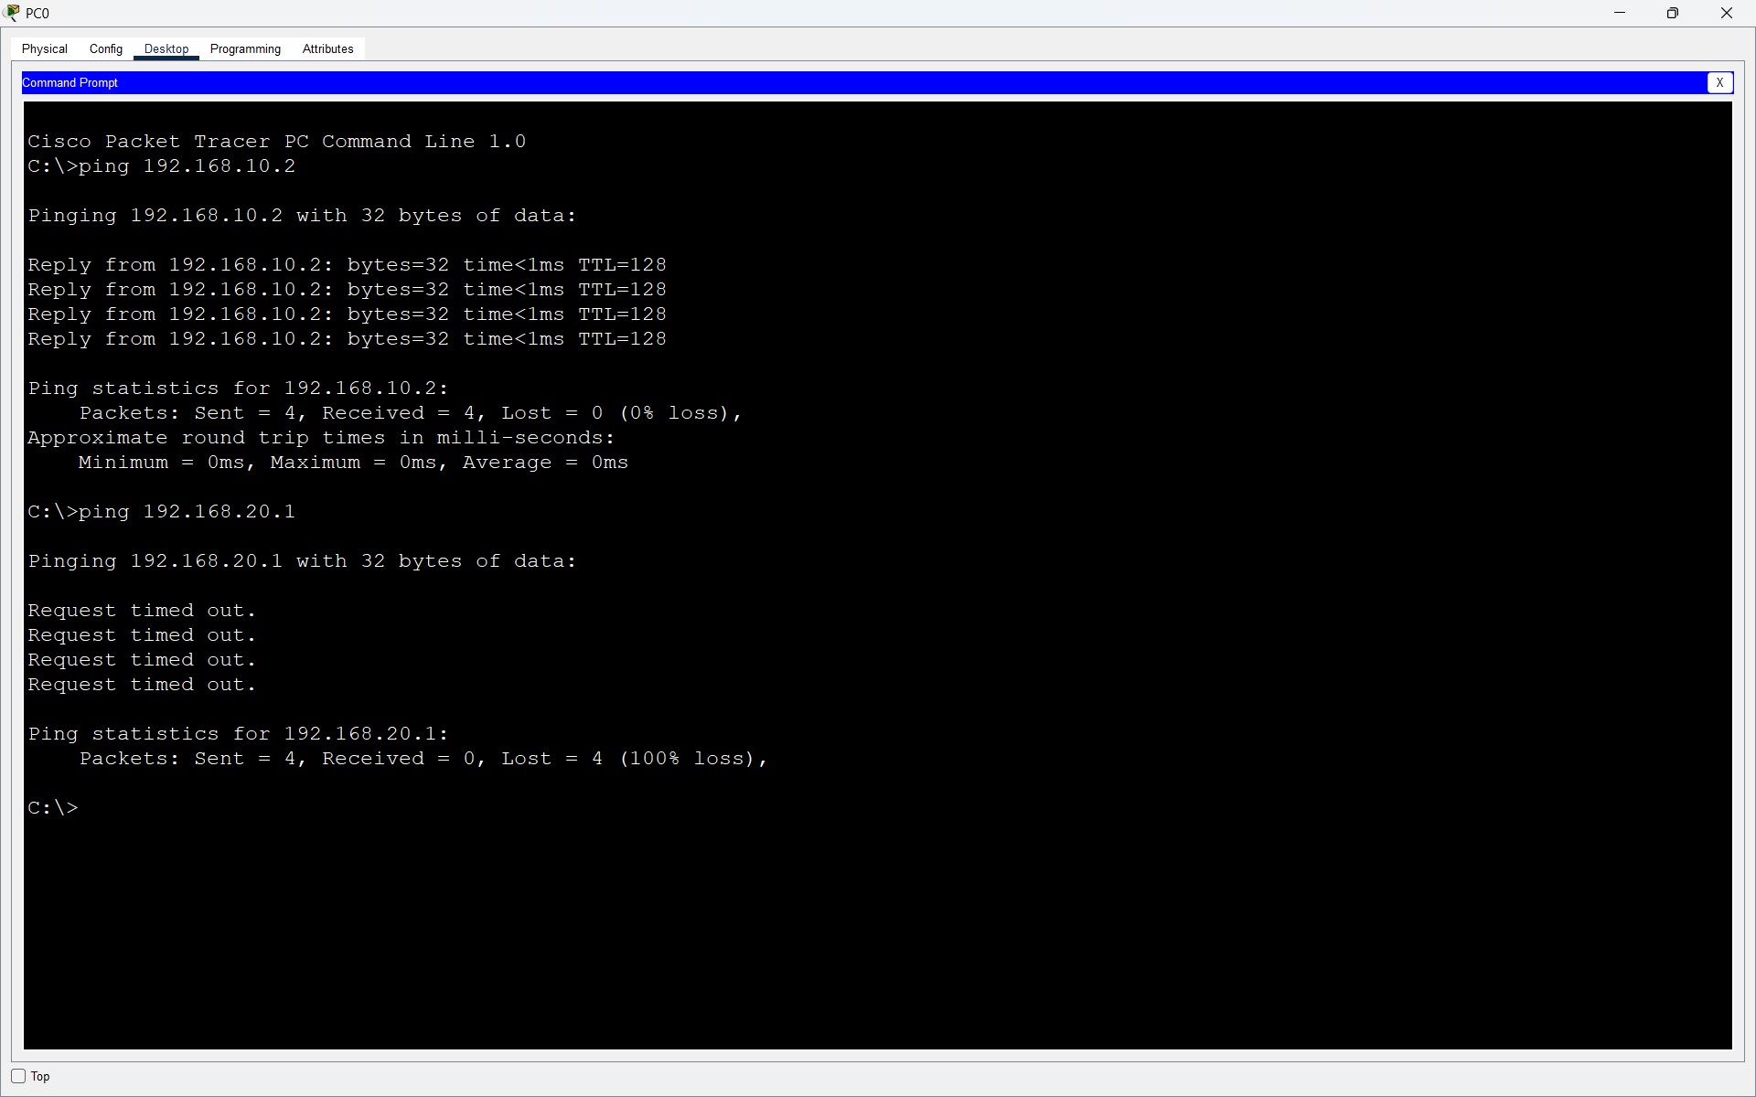
Result: PCs in different VLANs could not communicate with each other, confirming that VLAN 10 and VLAN 20 were successfully separated.

Q.3 In any network simulator, set up a scenario where you move a PC from VLAN 10 to VLAN 20. Show the before and after configuration commands and test connectivity to confirm the change?

Answer
- Moving a PC from VLAN 10 to VLAN 20
Initially, PC2 was connected to switch port Fa0/3 and assigned to VLAN 10.
- Before Configuration
interface fa0/3
switchport mode access
switchport access vlan 10
- Before the change:
- PC2 VLAN: VLAN 10
- PC2 IP Address: 192.168.10.3
- Port: Fa0/3

- After Configuration
I moved PC2 from VLAN 10 to VLAN 20 using:
- interface fa0/3
- switchport mode access
- switchport access vlan 20
I also changed PC2's IP address to:
192.168.20.3
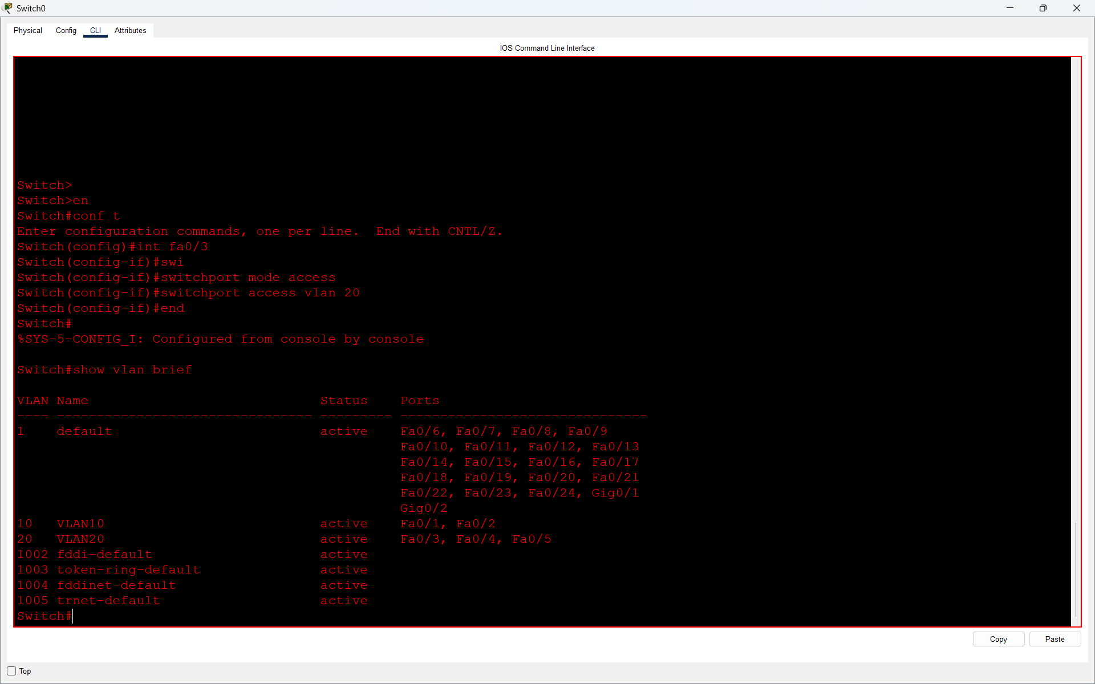
- Connectivity Test
PC2 successfully pinged a device in VLAN 20:
ping 192.168.20.2
The ping was successful with 0% packet loss.
PC2 then tried to ping a device in VLAN 10:
ping 192.168.10.1
The ping failed with 100% packet loss.
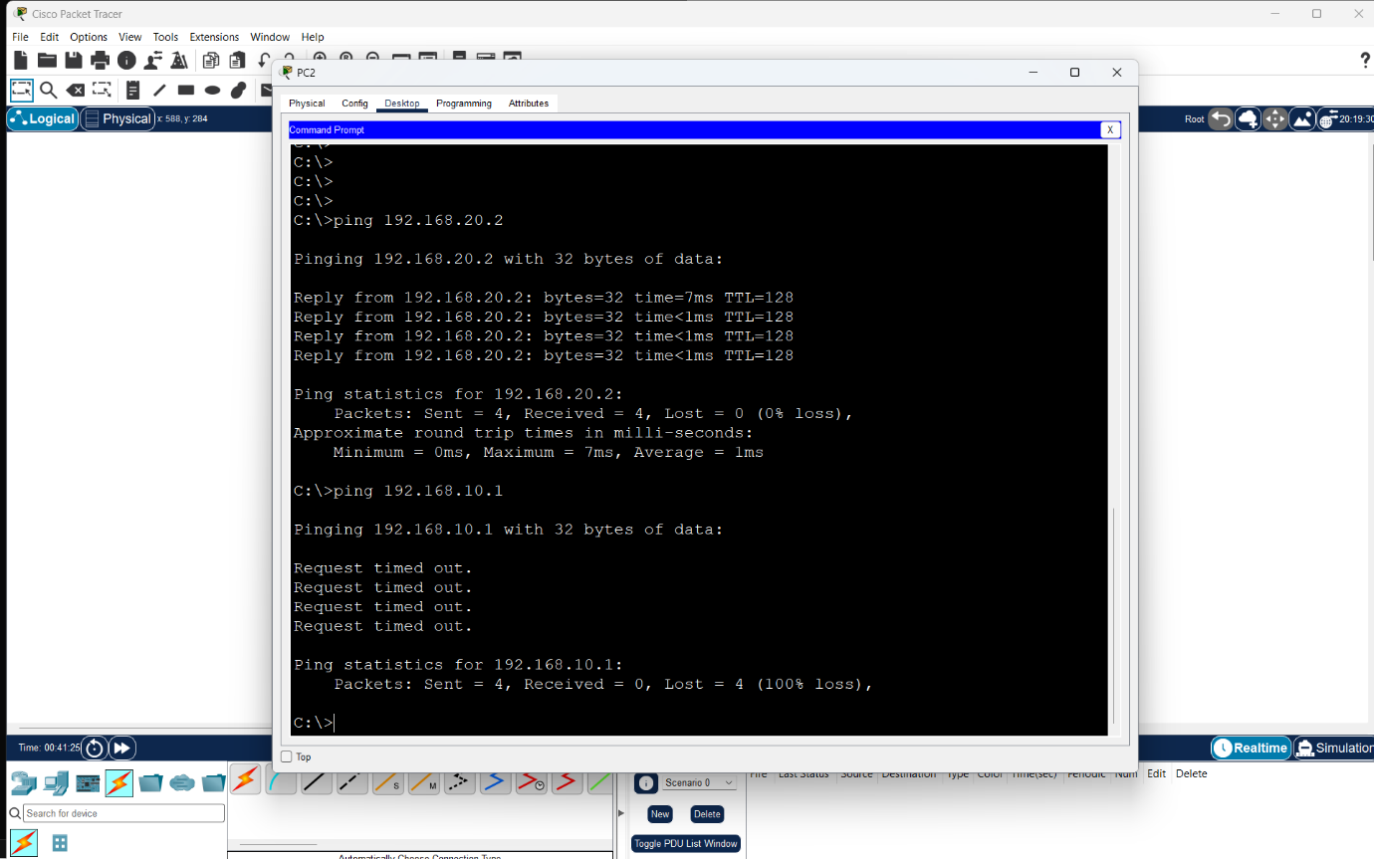
- Result
PC2 was successfully moved from VLAN 10 to VLAN 20. After the change, it could communicate with devices in VLAN 20 but could not communicate with devices in VLAN 10.

Q.4 Write a short script or command list that would automate assigning 10 ports on a switch to VLAN 30, using the syntax of your chosen simulator (Packet Tracer, NetSim, or GNS3).<br><br><em><strong>Constraint:</strong> Use a loop or range command if supported by the tool to avoid repeating the same command 10 times.</em>?

Answer

- Assigning 10 Switch Ports to VLAN 30
I used the interface range command in Cisco Packet Tracer to assign 10 switch ports to VLAN 30 at the same time.
- Command Used:
- enable
- configure terminal
- vlan 30
- name VLAN30
- exit
- interface range fa0/6-15
- switchport mode access
- switchport access vlan 30
- end
- show vlan brief
- Ports Assigned to VLAN 30:
Fa0/6 to Fa0/15
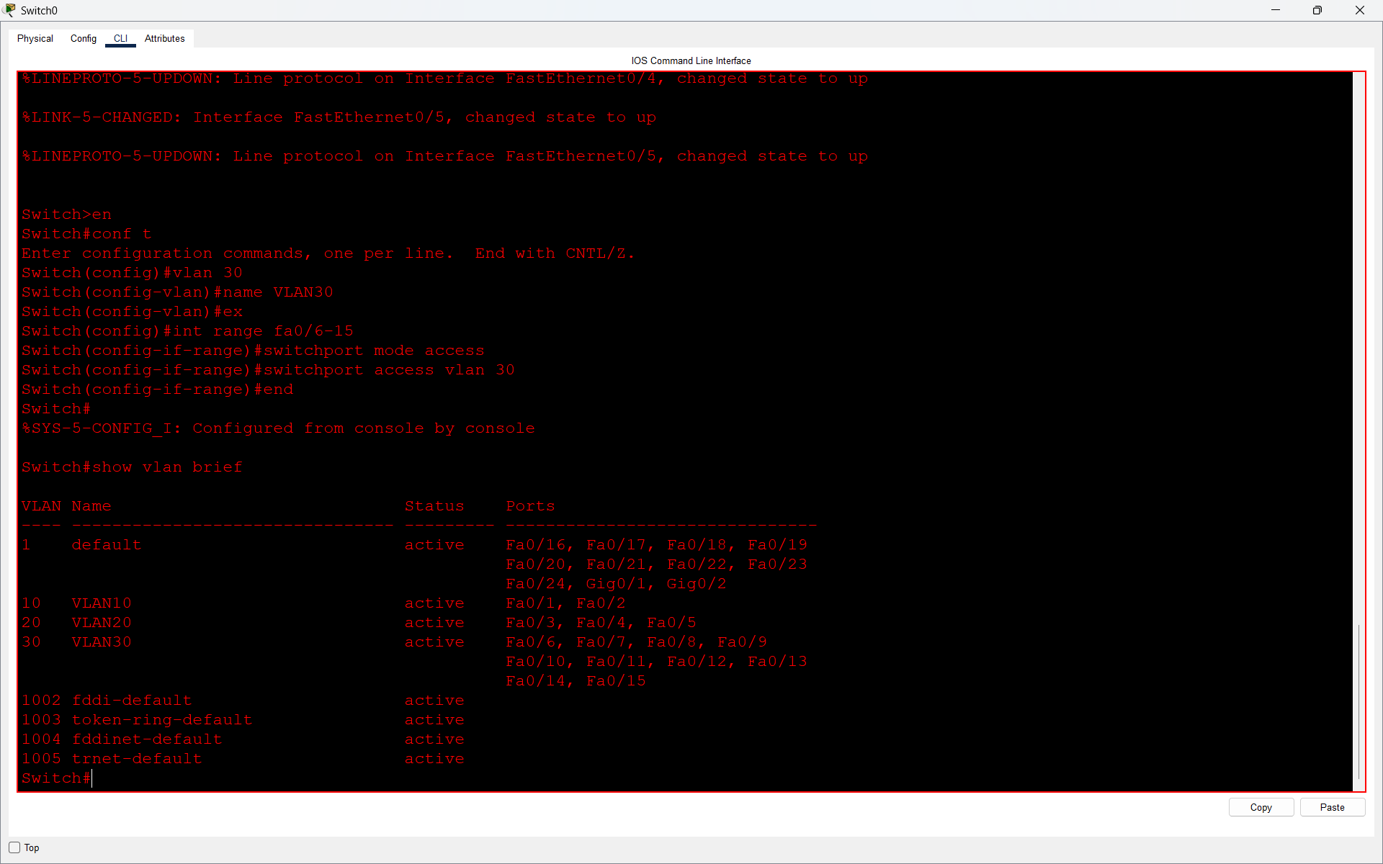

- Result:
The show vlan brief command confirmed that all 10 ports were successfully assigned to VLAN 30. Using the range command avoided repeating the same command for each port separately.

